2MP 52x Zoom Camera Module

SOAR-CB2252
- Max Resolution: 2MP (1920×1080), Max Output: Full HD 1920×1080@30fps Live Image
- Support H.265/H.264 Video Compression Algorithm, Multi-level Video Quality Configuration and Encoding Complexity Settings
- Starlight Low Illumination, 0.0005Lux/F1.4 (Color), 0.0001Lux/F1.4 (B/W), 0 Lux with IR
- 52x Optical Zoom, 16x Digital Zoom

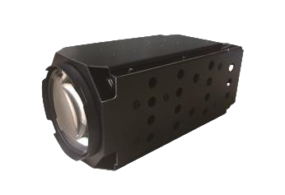

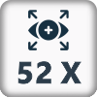

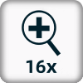
- Support Area Intrusion Detection, Cross-border Detection,
Movement Detection
- Support Onvif



- ICR Automatic Switching, 24 Hours Day and Night Monitor
- Support Backlight Compensation, Automatic Electronic Shutter,
Adapt to Different Monitoring Environment
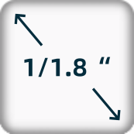

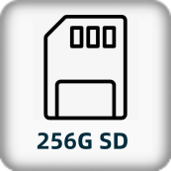
- Support 3D Digital Noise Reduction, High light Suppression,
Electronic Image Stabilization, 120dB Optical Width Dynamics
- Support 255 Presets, 8 Patrols
- Support Timed Capture and Event Capture
- Support One-click Watch and One-click Cruise Functions

- Specification
Camera
Image Sensor | 1/2.8" progressive scan CMOS
Min. Illumination | Color: 0.0005 Lux @(F1.4, AGC ON)
Min. Illumination | Black: 0.0001 Lux @(F1.4, AGC ON)
Shutter Time | 1/25~1/100,000 s
Automatic Aperture | DC drive
Day& Night | ICR
Digital Zoom | 16x
Lens
Focal Length | 6.1-317mm, 52x Optical Zoom
Aperture Range | F1.4-F4.7
Field of View | H: 61.8-1.6° (Wide - Tele)
Working Distance | 100mm-2000mm (Wide - Tele)
Zoom Speed | Approximately 6s (optional, wide-tele)
Compression Standard
Video Compression | H.265 / H.264
H.265 encoding type | Main Profile
H.264 encoding type | Base Line Profile / Main Profile / High Profile
Video Bitrate | 32 Kbps~16Mbps
Audio Compression | G.711alaw/G.711ulaw/G.722.1/G.726/MP2L2/PCM
Audio Bitrate | 64Kbps(G.711)/16Kbps(G.722.1)/16Kbps(G.726)/32-192Kbps(MP2L2)/16-64Kbps(AAC)
Image
Main Stream Resolution | 50Hz: 25fps (1920 × 1080, 1280 × 960, 1280 × 720); 60Hz: 30fps (1920 × 1080, 1280 × 960, 1280 × 720)
Third Stream Resolution and Frame Rate | Independent of main stream settings, supports up to: 50Hz: 25fps (704 × 576); 60Hz: 30fps (704 × 576)
Image Setting | Corridor mode, saturation, brightness, contrast and sharpness can be adjusted by client or browser
Backlight Compensation | Support
Exposure Mode | Automatic exposure/aperture priority/shutter priority/manual exposure
Focus Control | Auto focus/one focus/manual focus/Semi-Auto Focus
Area Exposure/Focus | Support
Day &Night | Auto(ICR) / Color / B/W
3D Noise Reduction | Support
Image overlay | Support BMP 24 bit image overlay, optional region
ROI | ROI supports one fixed region for each three-bit stream
Network Function
Network Storage | Built-in memory card slot, support Micro SD/SDHC/SDXC, up to 256 GB; NAS (NFS, SMB/ CIFS)
Protocol | TCP/IP,ICMP,HTTP,HTTPS,FTP,DHCP,DNS,RTP,RTSP,RTCP,NTP,SMTP,SNMP,IPv6
Interface Protocol | ONVIF(PROFILE S,PROFILE G)
Smart Function
Intelligent Detection | Cross boundary detection, area intrusion detection, exit area detection, wandering detection, people gathering detection, fast motion detection
Interface
External interface | 36pin FFC (Including network ports、RS485、RS232、CVBS、SDHC、Alarm In/Out、Line In/Out、Power), USB
General
Working Environment | -30℃~60℃; Humidity less than 95% (non-condensing)
Power supply | DC12V±10%
Consumption | 2.5W MAX (IR, 5.5W MAX)
Dimensions | 175.5x75x78mm
Weight | 925g

Dimension
